SQL Prompt for Visual Studio Enterprise 2017

Lab version: 15.0.26020.0

Last updated: 2/15/2017

**TABLE OF CONTENTS**

Overview 1

Pre-requisites 1

Task 1: Writing our first query with SQL Prompt 1

Task 2: Create a stored procedure 2

Task 3: Expanding Wildcard Characters 2

Task 4: Finding a table name 3

Task 5: Adding JOIN Conditions 3

Task 6: Including WHERE Clause 4

Task 7: Writing INSERT Statements 5

Task 8: Testing our stored procedure 6

Summary 6

## Overview

SQL Prompt for Visual Studio Enterprise is an add-in for Visual Studio that extends and enhances the standard IntelliSense-style code completion. SQL Prompt can make your developers twice as fast at working with SQL, and leaves them free to concentrate on how the code actually works.

It helps your team work with each other’s code and write consistent queries.

Using SQL Prompt allows you to improve productivity by stripping away the repetition of coding. As well as making the most common queries, such as SELECTs and INSERTs, quick to write, SQL Prompt completes JOIN conditions for you automatically. You don't have to remember any column names or aliases.

## Pre-requisites

In order to complete this lab you will need the Visual Studio 2017 virtual machine provided by Microsoft. For more information on acquiring and using this virtual machine, please see [this blog post](http://aka.ms/almvm).

Let’s connect to a database from the Server Explorer window in Visual Studio* *and take a look at some of the highlights*

### Task 1: Writing our first query with SQL Prompt

1. Open Server Explorer and Connect to the ***PartsUnlimited*** database
2. Right click on the database and select **New Query**
3. Let's assume we need to write a stored procedure on the ***Orders*** table

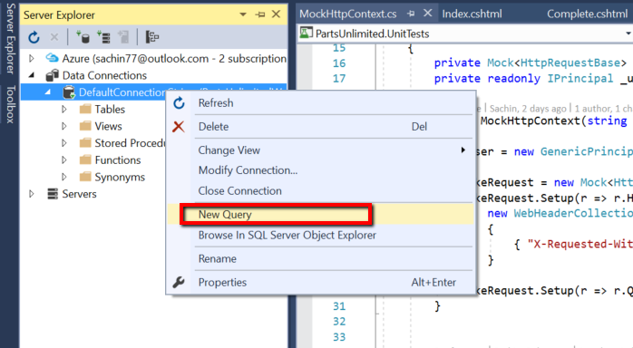

1. Hit the spacebar to invoke SQL Prompt
2. Type ‘SE’ complete to SELECT Type ‘* F’ complete to FROM
3. Select **Order** from the drop-down

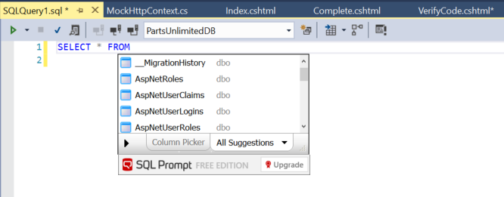

*As you can see it also qualifies and uses square brackets where necessary Go – Execute query*

--Code completions for T-SQL Commands

SELECT * FROM dbo.[Order]

### Task 2: Create a stored procedure

In addition to this it also works with Keywords, lets create a stored procedure to retrieve all ***Orders***

1. Type ‘CR’ complete to *CREATE* and Type ‘PRO’ complete to *PROCEDURE*

2. Type ‘GetOrders A’ complete to *AS*

3. Provide a name for the stored procedure

4. Type ‘BE’ complete to *BEGIN*

5. Repeat Section B1-3 to add select statement

6. Type ‘E’ complete to *END*

1. Go – Execute query

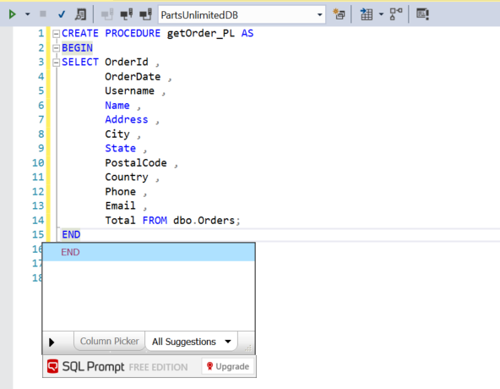

*-Code completion of keywords*   
CREATE PROCEDURE GetOrders AS   
BEGIN   
 SELECT FROM dbo.[Order]   
END  
GO

### 

### Task 3: Expanding Wildcard Characters

It’s easy for us to work with ‘SELECT ’ but really we want to be specific about the columns we are selecting, with SQL Prompt we canexpand wildcard with our completion key.

1. Place cursor to the right of ‘*’ in existing SELECT statement

2. Press ‘Tab’ to expand

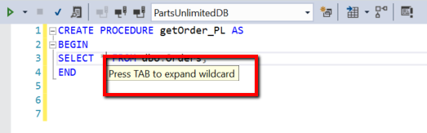

3. Highlight ‘CREATE’

4. Type ‘AL’ complete to ALTER

5. Execute Query

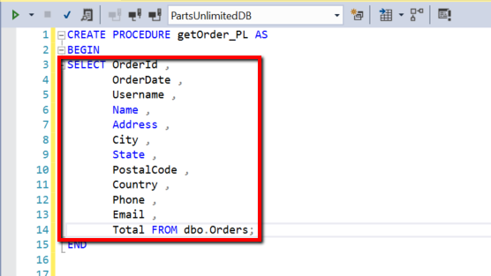

--Expansion of Wildcard  
ALTER PROCEDURE GetOrders AS  
BEGIN  
SELECT [Order].OrderId ,  
 [Order].Address ,  
 [Order].City ,  
 [Order].Country ,  
 [Order].Email ,  
 [Order].FirstName ,  
 [Order].LastName ,  
 [Order].OrderDate ,  
 [Order].Phone ,  
 [Order].PostalCode ,  
 [Order].State ,  
 [Order].Total ,  
 [Order].Username FROM dbo.[Order]  
END  
GO

### Task 4: Finding a table name

What if we wanted to connect this information to our User information? As well as mid-string matching, SQL Prompt also allows CamelCase suggestions

1. Type SELECT * FROM

2. Type ‘NU’ complete AspNetUsers from CamelCase matches

3. Go – Execute Query

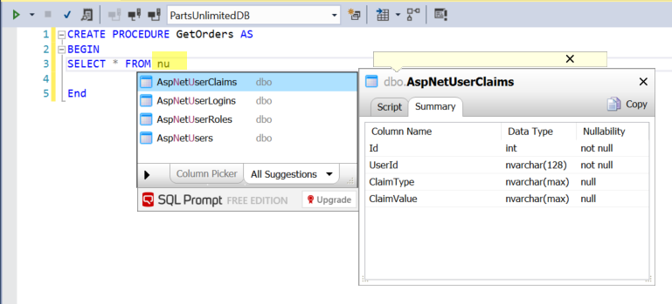

--CamelCase 'I know I want a User table but what is it called'  
  
SELECT * FROM dbo.AspNetUsers -- Use nu  
  
GO

### Task 5: Adding JOIN Conditions

there is no foreign key relationship to Order here but SQL Prompt will still suggest a join condition based upon the matching column names

1. Repeat earlier steps to get *SELECT*  FROM dbo.[Order]

*2. Type ‘JO’ complete* JOIN*   
3. Type ‘NU’ complete *AspNetUsers*

4. Type ‘ON ’ complete suggested join on UserName

5. Go – Execute Query

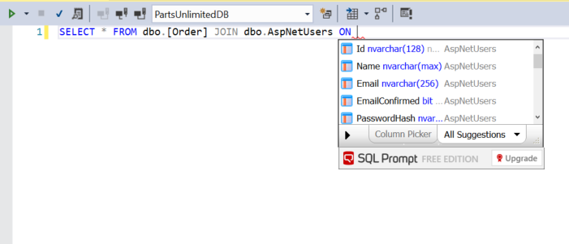

*--Join conditions without foreign keys*  
  
**SELECT** * **FROM** dbo.[**Order**] **JOIN** dbo.AspNetUsers **ON** AspNetUsers.UserName = [**Order**].Username  
  
GO

### Task 6: Including WHERE Clause

Let’s wrap this up in a stored procure to retrieve details of a specific order and user

1. Type ‘CR’ complete to CREATE

2. Type ‘PRO’ complete to PROCEDURE

3. Type ‘GetOrder @ID A’ complete to AS

4. Type ‘BE’ complete to BEGIN

5. Repeat Section F1-4 to add select statement

6. Type ‘WH’ complete to WHERE

7. Type ‘ ‘ select OrderID

8. Type ‘@’ complete to @ID

9. Type ‘E’ complete to END

10. Optionally expand the wildcard again

11. Go – Execute query

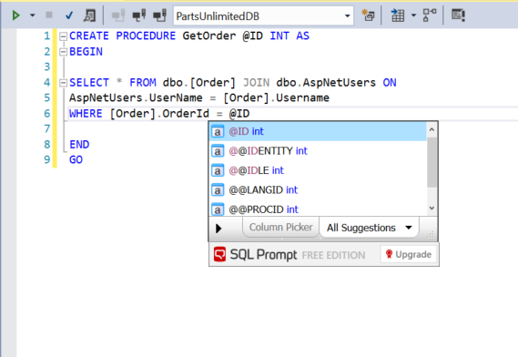

*--Code highlighting*   
  
**CREATE** **PROCEDURE** GetOrder @ID INT **AS**  
**BEGIN**  
  
**SELECT** * **FROM** dbo.[**Order**] **JOIN** dbo.AspNetUsers **ON**  
AspNetUsers.UserName = [**Order**].Username   
**WHERE** [**Order**].OrderId = @ID  
  
**END**  
GO

### Task 7: Writing INSERT Statements

Next let’s add a new order record to check we can retrieve it - SQL Prompt autocompletes insert statements with column lists for us too***

1. Type ‘IN’ complete to *INSERT*

2. Type ‘INT’ complete to *INTO*

3. Select Order complete to full column list

4. Update the VALUES with some made up data (N’Made up data’)

5. Ensure the UserName value is N’Administrator@test.com’

6. Go - Execute Query

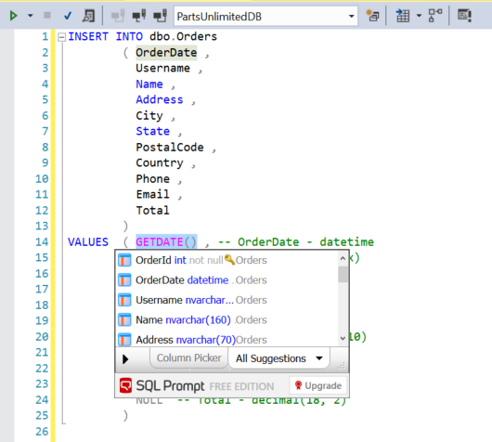

*--Insert statements completing with column list*  
  
**INSERT** **INTO** dbo.[**Order**]  
 ( Address ,  
 City ,  
 Country ,  
 Email ,  
 FirstName ,  
 LastName ,  
 OrderDate ,  
 Phone ,  
 PostalCode ,  
 State ,  
 Total ,  
 Username)  
  
**VALUES** ( N'123 Some Street' , *-- Address - nvarchar(max)*  
 N'Seattle' , *-- City - nvarchar(max)*  
 N'USA' , *-- Country - nvarchar(max)*  
 N'admin@test.com' , *-- Email - nvarchar(max)*  
 N'Tom' , *-- FirstName - nvarchar(max)*  
 N'Austin' , *-- LastName - nvarchar(max)*  
 SYSDATETIME() , *-- OrderDate - datetime2*  
 N'5551235897' , *-- Phone - nvarchar(max)*  
 N'99999' , *-- PostalCode - nvarchar(max)*  
 N'WA' , *-- State - nvarchar(max)*  
 39.99 , *-- Total - decimal*  
 N'Administrator@test.com' *-- Username - nvarchar(max)*  
 )

Let’s check it is in the Table

### Task 8: Testing our stored procedure

Lets test our stored procedure, when writing EXEC statements SQL Prompt even include a parameter list for us:

1. Run ***SELECT*  FROM dbo.[Order]**\* and note the OrderID from the results
2. Type ‘EX’ complete to EXEC
3. Select ‘GetOrder’
4. Edit the value to match the OrderID from I2.
5. Execute Query

--Auto-complete EXEC statements with parameter lists  
  
EXEC dbo.GetOrder @ID = 2 -- int

## Summary

There’s a quick tour of the highlights of SQL Prompt Free Edition. It’s available in Visual Studio Enterprise 2017 and it improves your productivity by speeding up SQL development tasks and reducing risk of e rror, so you can get back to the task in hand.